Windows DJI Player

Installation Instructions

**Important:**

This software is super duper test phase and comes with no warranty of any kind, express or implied. This includes no warranty as to the suitability of the software for a given task. Having said that, it is working great for me.

**Notes:**

Using this player on Windows is much more painful than on Linux or macOS. The reasons are as follows (in no particular order):

* Need to install a USB generic driver that binds to the DJI headset
* Named pipes for directly wrapping the video feed to ffplay require Admin rights
* This will not work if there is an SD card for recording in the headset

This document briefly outlines the process to get the code running on Windows. Comfort with some command-line things is required for this process.

I will work on posting some pre-built artifacts to the Github releases page.

Following this process **\*may\*** prevent the DJI Installer / activation tool from talking to the headset unless reversed. Since there are no more updates coming for the headset, and it is already activated, I assume this is not an issue.

**Prerequisites at Time of Writing:**

* DJI Player Source Tree, downloadable from:  
  <https://github.com/hcardwell/usb-vsp/archive/refs/heads/master.zip>
* Zadig 2.5 (to configure the USB device driver binding)
* Python Windows 3.9.5 amd64
* Libusb for Windows libraries, downloadable from:  
  https://github.com/libusb/libusb/releases
* FFMpeg (version whatever, 4.4.78 at time of writing, downloaded here):  
  <https://github>.com/BtbN/Ffmpeg-Builds/releases
* Git, to grab the software repository
* Internet access for the installation process

Screenshot on the test setup I used for creating this document:

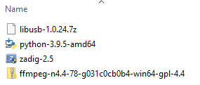

**USB Setup:**

* Connect the DJI v1 (untested with v2) headset, powered to your Windows machine. Wait for Windows to report installation success:  
  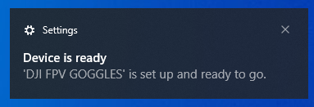
* (Optional) Open the Windows Device Manager (devmgmt.msc) and verify an unattached “BULK Interface”:  
  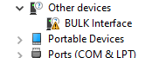
* Run Zadig (requires elevation) and it should detect the BULK Interface, and give you the option to install a USB driver for it:  
  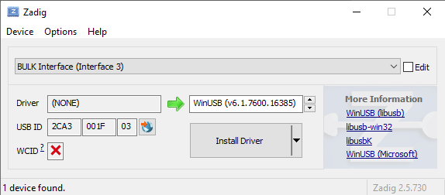
* Click “Install Driver” to install WinUSB for the BULK Interface:  
  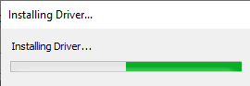
* The installation will take a few moments, and should report success:  
  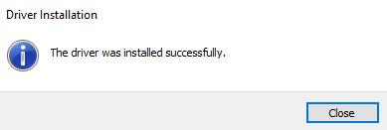
* Close Zadig
* Unplug and power off the DJI headset for the time being

**Python Setup:**

* Run the Python 64-bit installer
* Select “Customize installation”
* Leave all components selected
* Select to install for All Users, and change the taget installation directory to C:\Python39:  
  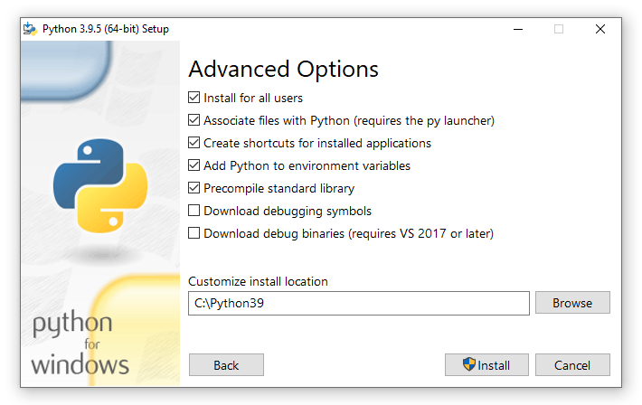
* Close the success window. No need to disable the path length limit for this application

**Install FFMpeg:**

Video playback depends on the ffplay binary from the FFMpeg project. The Windows version of the DJI player expects to find the ffplay binary at “c:\ffmpeg\current\bin\ffplay.exe”. You cant edit the winplayer.py file to change this location. These installation instructions place ffmpeg in that directory.

* Right-click on the ffmpeg archive downloaded from the above URL and click “Extract All”
* Change the destination path to “C:\ffmpeg”:  
  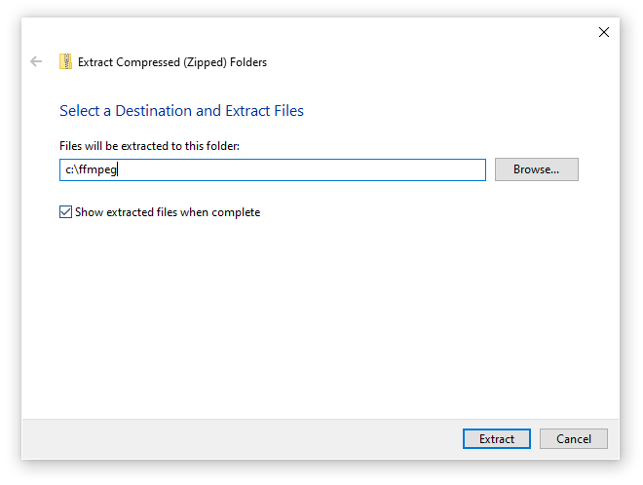
* Click “Extract”
* After the files have been installed, a new window will open showing a folder with the installed version of ffmpeg. Right-click on the folder, select “Rename”, and rename the folder to “current”:  
  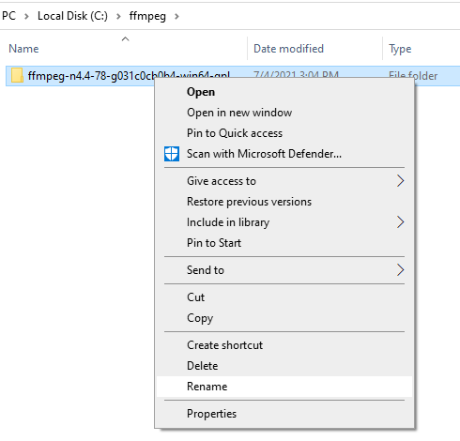
* Should look like this:  
  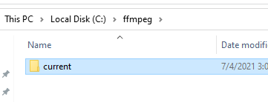

**Install / Prep the DJI Player Code:**

* Extract the source tree download for the player to c:\src\djiplayer. When complete and you have things in the right place, you should have this:  
  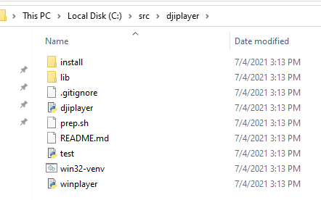
* Open a command prompt as administrator (sadly required for the USB stuff and the named pipes) by clicking start, typing “command prompt”, right-clicking on it, and selecting “Run as administrator”
* Change to the directory containing the player by typing “cd \src\djiplayer” and pressing enter
* Run the command “python --version" (that is python, two dashes, and version) to verify that python is working and available:  
  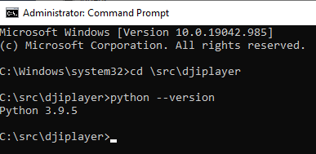
* Type “win32-venv.bat” to run the script to create the Python virtual environment and install the python USB library into it. You can ignore warnings about an old version of PIP:  
  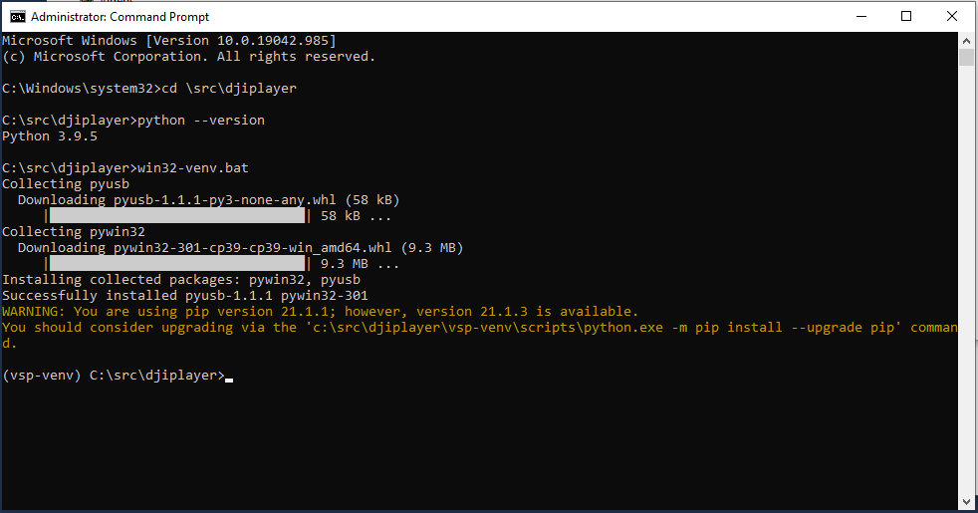
* You will need to extract the Windows libusb-1.0.dll file from the libusb download linked above, and place the DLL file in c:\src\djiplayer\vsp-venv-Scripts. This will allow the Python virtual environment to have access to the libusb library without installing it system-wide. Google for additional help on this step if needed. The correct library is in the archive under VS2019\MS64\dll\:  
  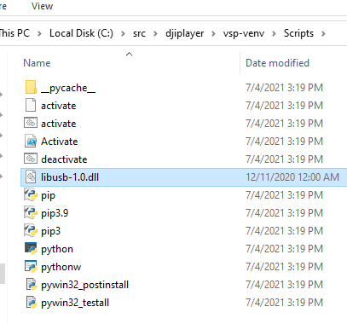
* With that DLL file installed in the Scripts directory, the player should be ready to operate
* Close all open windows and proceed to running the player

**Run the Windows DJI Player:**

* Open a command prompt as administrator (sadly required for the USB stuff and the named pipes) by clicking start, typing “command prompt”, right-clicking on it, and selecting “Run as administrator”
* Change to the directory containing the player by typing “cd \src\djiplayer” and pressing enter
* Type “win32-venv.bat” to run the script to load the Python virtual environment:  
  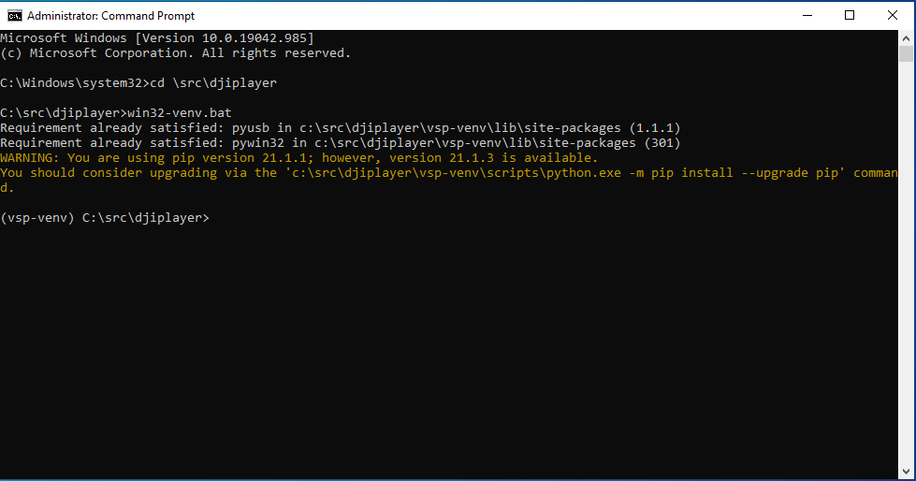
* Type “python winplayer.py” to start up the player:  
  
* The program should report that it is waiting for a detected headset
* Power on and plug in your DJI headset via a USB A-to-C cable

From this point, the headset should be detected and the player will report that it is sending the stream initialization command to the headset. It should then report that it is waiting for a stream. Once picture is visible in the headset it should begin “player” the stream full screen using FFPlay. Disconnecting the headset will shutdown the player, and the program should report that it is waiting for a headset again.

On Windows, some “Operation timed out” errors are a normal part of the debug build. Do not be alarmed.

**Troubleshooting:**

* If the above instructions are followed exactly, it should work. They are not forgiving of skipping steps
* If the headset is detected but the stream does not start playing (but is visible in the goggles), disconnect from the PC, wait 5 seconds, and then reconnect to see if the stream starts then
* If the headset is not detected at all, verify you copied the libusb-1.0.dll to the venv “Scripts” folder and verify that the WinUSB driver is attached via Zadig